***MG-APP* User Manual**

**Multi-GNSS Automatic Precise Positioning software**

written by Gongwei Xiao

Email: xiaogongwei@asch.whigg.ac.cn

QQ Group: 258113285

Last modified: Feb 11, 2020



**Institute of Geodesy and Geophysics,**

**Chinese Academy of Sciences**

**1 Introduction** 1

**2 Supported platforms** 2

**3 Installation** 2

**3.1 Install Qt** 2

**3.2 Build and Run** 3

**3.3 Processing strategies and processes** 4

**4 GNSS data processing** 5

**4.1 Single station processing** 5

**4.2 Multiple station processing** 7

**5 File format description** 8

**6 Thanks & Support** 14

**7 References** 15

**1 Introduction**

The open-source MG-APP is developed based on the GNU General Public License version 3 (GPLv3) protocol, and includes all of the C++ and Qt source code. The software provides a rich function library that makes subsequent development easier, and can run on UNIX/Linux, Windows, and other operating systems. MG-APP adopts precise point positioning (PPP) mode of ionosphere-free combination to process data of GPS, GLONASS, BeiDou (BDS), and Galileo systems. It can process not only static data, but also dynamic observed data. MG-APP implements multiple filtering modes: Kalman filter, and the Square Root Information Filter (SRIF). Also, MG-APP software uses phase-smoothed pseudoranges to improve the precision of the pseudorange positioning. Both the PPP mode based on precision products and the single point positioning (SPP) using a broadcast ephemeris is available for the choices. Meanwhile, a variety of commonly used tropospheric estimation models, such as UNB3m, Saastamoinen (GPT2), and Hopfield (GPT2) are provided for users to study the effects of different tropospheric models on PPP positioning. Users need not care about the format of observed data (Rinex3.x and Rinex2.x) and broadcast ephemeris file types (N files, P files). The software can automatically download prerequisite products for processing if the products are not present. Further more, The software can automatically process the observed data in batches. During the data processing, it needs the observed data of only two adjacent epochs and adopts real-time processing data mode according to the filtering algorithm to study the PPP convergence process by using either the forward or backwards filtering; high-precision products are obtained by backwards filtering.

The main features of the software are as follows:

1. It can read the data files needed for precise point positioning (PPP): observation data (*.*o), satellite precise orbit data (*.sp3), satellite clock offset data in 5 minutes or 30 seconds (*.clk or *.clk_*), earth rotation parameter data (*.erp), ocean tide data (*.blq), satellite and receiver antenna data (*.atx), global tropospheric grid data (*.grd), and so on.

2. Two different filtering algorithms are implemented to process epoch observation data: SRIF and Kalman filter.

3. It can automatically download necessary products, and processes single station or multiple stations.

4. Cross-platform & Easy portability: MG-APP was tested under Linux and Windows systems, and the source code can generate executable an program directly without changing any lines of code. It takes about six to eight seconds to calculate one day of observed data with a sampling interval of 30s.

5. The detailed results generated from the calculation process are saved into files for further data analysis. The results include positioning results, zenith tropospheric delays (ZTDs), receiver clock offsets, satellite ambiguity parameters, observation value residuals, and other detailed data.

**2 Supported platforms**

The MG-APP software was developed in the C++ language based on the cross-platform [Qt](https://www.qt.io/) framework. It can be compiled and executed on popular operating systems such as Windows, UNIX/Linux, Mac, and other operating systems. It is recommended to debug MG-APP under Qt Creator in UNIX/Linux or Windows system. Computer configuration requirements as follows:

**Operating system:** Linux or Windows

**System type:** 32 or 64 bit

**Memory:** at least 512MB

**Hard disk space:** hard disk at least 500MB

**Qt Version:** Qt version higher than 5.8.0

All the operation examples and the performance of the software demonstrated in the following content are recorded under the Windows 10 system, including software installation and testing. The software was also tested under the Ubuntu system with the version equal to 16.04 or higher, and the tests passed.

**3 Installation**

**3.1 Install Qt**

Users need to install Qt5.8.0 from Qt official website (www.qt.io) to open project and recompile to generate the required executable program under operating system. Download: <http://download.qt.io/archive/qt/5.8/5.8.0/>. if you use Windows system, please choose: "[qt-opensource-windows-x86-mingw530-5.8.0.exe](http://download.qt.io/archive/qt/5.8/5.8.0/qt-opensource-windows-x86-mingw530-5.8.0.exe)". If you use Linux, choose the "[qt-opensource-linux-x64-5.8.0.run](http://download.qt.io/archive/qt/5.8/5.8.0/qt-opensource-linux-x64-5.8.0.run)". If you use Mac, choose the "[qt-opensource-mac-x64-clang-5.8.0.dmg](http://download.qt.io/archive/qt/5.8/5.8.0/qt-opensource-mac-x64-clang-5.8.0.dmg)". When you install Qt5.8.0, you need to choose MinGW 5.3.0 32-bit based on your operating system. As shown in Fig. 1.

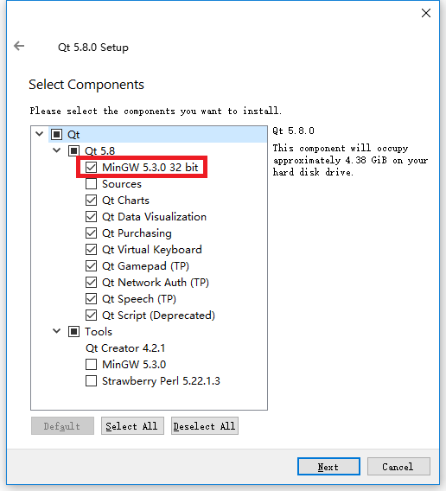

**Fig. 1 C**hoose MinGW depending on operating system

**3.2 Build and Run**

After the installation of Qt is finished, user can open the Qt Creator and click the menu bar "File->Open File or Project..." to open "MG_APP.pro" in the source folder MG_APP, and you will see the window shown in Fig. 2 (Qt Creator has a uniform interface in Windows, UNIX/Linux, Mac, and other operating systems). MG-APP can be compiled and run after the triangular button has been clicked.

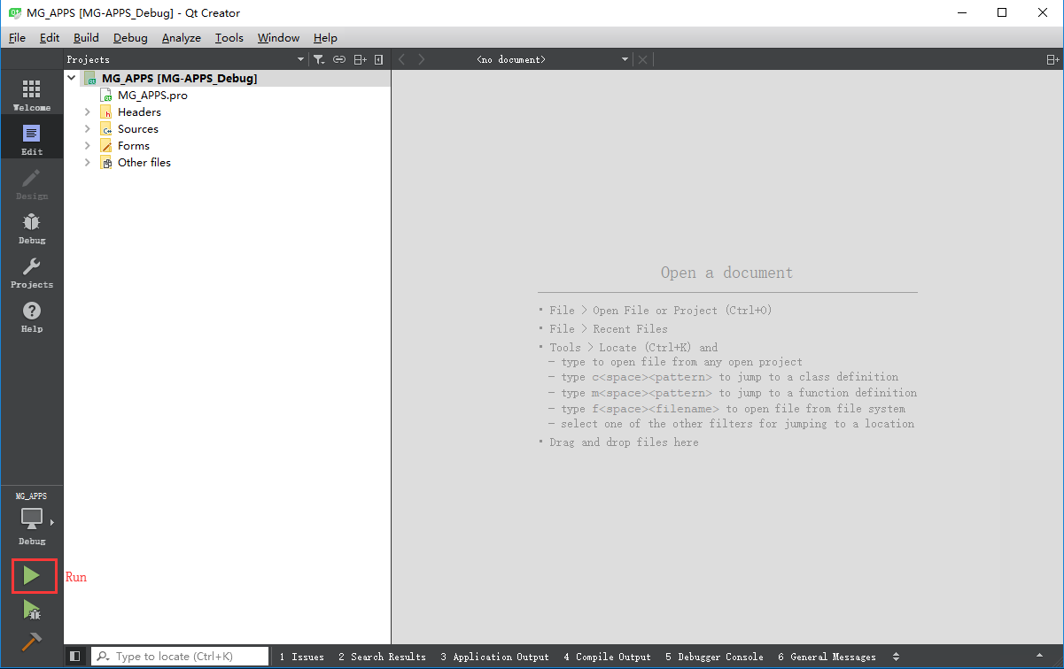

**Fig. 2** The Qt window in Win10 system

After clicking "Run" button in Fig. 2, the main window of MG-APP will appear as shown in Fig. 3.

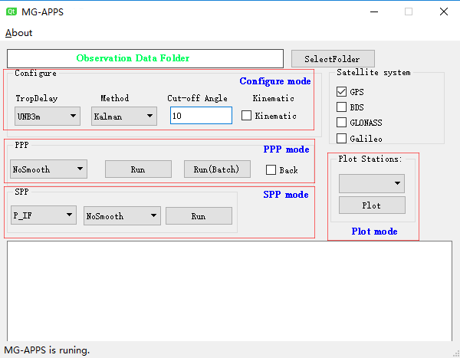

**Fig. 3** The MG-APP window

NOTE: Before processing the data, the debugger in **debug mode** must copy five items "gpt2_5.grd", "igs14_2035.atx", "gzip.exe", "OCEAN-GOT48.blq", "widget.ico" and “images” folder from the "MG_APP/resources/CopyData" folder to the "build-MG_APP-***-Debug/**debug**" folder which generate in the same directory as MG_APP folder (if debugger in **release mode,** five items should be copy into the " build-MG_APP-***-Debug/**release**" folder).

**3.3 Processing strategies and processes**

To facilitate users familiar with the process of software processing, the basic strategy of The GNSS data processing flow under PPP mode of MG-APP is shown in the ensuing content. Table 1 shows the GNSS data processing strategy and Fig. 4 shows the flows in MG-APP. In Fig. 4, the block labelled single point positioning (SPP) represents the function of calculating approximate coordinates using broadcast ephemeris, the output file labelled keyhole markup language (KML) can be displayed on Google Earth, and the block labelled Image presentation software generates image files in PNG format.

**Table 1** MG-APP strategy on GNSS data processing

|  |  |
| --- | --- |
| Items | Processing strategies |
| Navigation constellation | GPS(default)/GLONASS/BDS/Galileo |
| Observation model | Ionosphere-free combination |
| Processing mode | Static (default)/Dynamic |
| Satellite orbit and clock | GBM/IGS product (automatic download) |
| Cut-off mask angle | 10º (default) |
| Observation weight | $P=\sin^{2}{e}/σ^{2}$ ( $σ^{2}$ indicates variance of pseudorange or carrier)  GPS: GLONASS: BDS: Galileo = 3:2:1:1 |
| Receiver clock offset and ISB | White noise estimation |
| Filtering method | Kalman(default)/SRIF |
| Satellite and receiver antenna correction | igs14_2035.atx, PCO: linear interpolation, PCV bilinear Interpolation |
| Phase wind-up model | Wu at al. 1993 |
| Tidal model | Solid Earth tide, ocean tide, pole tide  IERS conventions 2010 |
| Tropospheric zenith hydrostatic delay | UNB3m/Saastamoinen(GPT2)/Hopfield(GPT2) |
| Tropospheric zenith wet delay | Random walk estimation |
| Ambiguity parameter | Ionosphere-free model floating-point ambiguity |
| Tropospheric projecting function | Neil/VMF1/GMF(default) |

Neil(Neil, 1996), VMF1(Boehm et al. 2004), GMF(Boehm et al. 2006)



**Fig. 4** Flow for MG-APP processing a single station

**4 GNSS data processing**

**4.1 Single station processing**

This section mainly introduces the operation of single station data processing by MG-APP. At first, copy the observation file (*.*o) to the new folder (e.g., D:/ABMF0020). Then, click the "SelectFolder" button on the MG-APP panel to select the folder containing the obsevation file. Configure mode is used to configure the required parameters, such as tropospheric model, filtering method, cut-off angle and satellite system, etc. After clicking the "Run" button, MG-APP automatically downloads the necessary products (sp3, clk, etc.) to process these GNSS observation data under the precise point positioning mode. If there are sp3 and clk files prepared in the observation file folder in advance, MG-APP will adopt them and not waste time downloading the products itself. The process was shown in Fig. 5.



**Fig. 5** Flowchart of PPP processing using MG-APP

When the calculation is accomplished, push the “Plot” button to draw the figures to display the PPP solution visually. Four images like the left side of Fig. 6 will show up. They are the zenith tropospheric delays (ZTDs), the reference receiver clock offsets, the SPP results, and the positioning error of the PPP solution. MG-APP use the last epoch estimated position as the "true position" to plot error curve. The right side of Fig. 6 is kinematic PPP results, with SPP estimated positioning for each epoch.

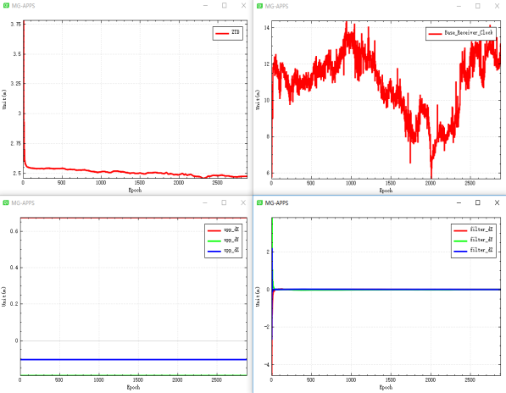 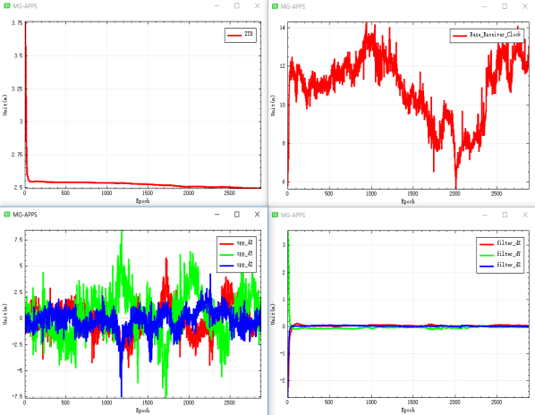

**Fig. 6** Processing PPP data in static (left) and kinematic (right) modes

Following the above steps, the static PPP data will be processed and the prefix with "Products_" folder will be generated under the observed data folder, which stores the positions of each epoch (position.txt), the satellite numbers (Epoch_PRN.txt), the ZTDs, receiver clocks (ZTDW_Clock.txt), the model corrections (Satellite_info.ppp). While the ambiguity parameters of each satellite are stored under the Ambiguity folder. Furthermore, MG-APP generates the position.kml file that can be loaded by Google Earth to display the antenna motion trajectory. The list of generated files is shown in Fig. 7.

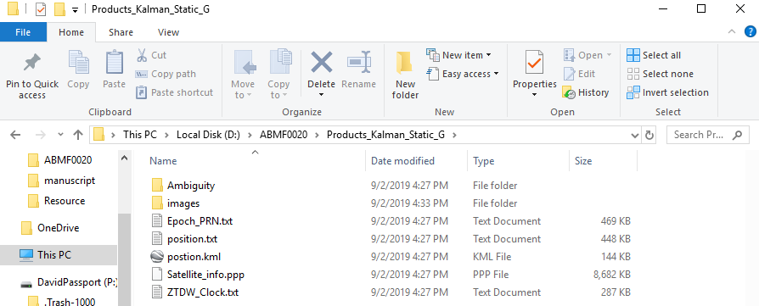

**Fig. 7** Result files generated by static PPP of single station

**4.2 Multiple station processing**

MG-APP can also batch process GNSS observation data for multiple stations. Put the GNSS observation data of multiple stations into the created folder as shown in upper portion of Fig. 8, then use the "SelectFolder" button to select the folder of multiple observation data, use the "Configure model" to configure the required parameters, and click the button "Run (Batch)" to process data of multiple stations. The MG-APP software will automatically download the required products (sp3, clk) and process these GNSS obsevation data under the precise point positioning mode. All calculating results will be saved under the "allStations" folder shown in the lower portion of Fig. 8.

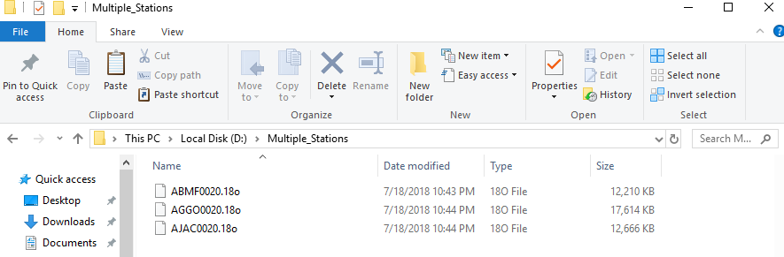

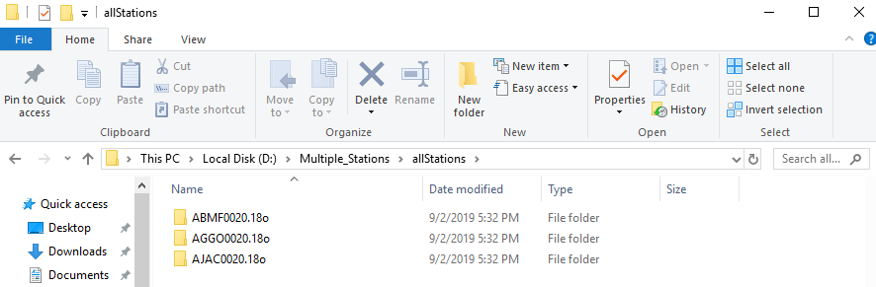

**Fig. 8** Result files generated by static PPP of multiple stations

When the operation is completed, you can select the station you want to plot and analyze from the drop-down menu in "Plot mode" as shown in Fig. 9. Then click on the "Plot" button to draw the four images shown in Fig. 6. When the plot finished, the four images will be saved under the "images" folder.

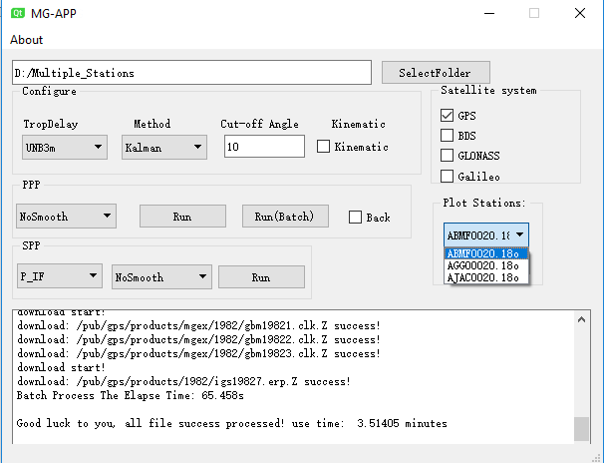

**Fig. 9** Processing results of multiple stations

**5 File format description**

1. position.txt

After processing the data, a position.txt file is generated by MG-APP which saves the epoch number, observation time, number of valid satellites, SPP coordinates, and PPP coordinates. The character position of each column is shown in Table 2. The screenshot of position.txt file shown in Fig. 10. The position.txt can be used to plot and analyze the coordinate sequence.

**Table 2** position.txt format description

|  |  |  |  |
| --- | --- | --- | --- |
| items | | value type | Beginning and ending bytes |
| epoch number | | int | 1-10 |
| observation time (GPST) | Year | int | 13-16 |
| Moth | int | 18-19 |
| Day | int | 21-22 |
| Hour | int | 24-25 |
| Minute | int | 26-27 |
| Second | double | 29-38 |
| number of valid satellites | | int | 51-52 |
| SPP (IGS14) | X(m) | double | 55-69 |
| Y(m) | double | 72-86 |
| Z(m) | double | 89-103 |
| PPP (IGS14) | X(m) | double | 106-120 |
| Y(m) | double | 123-137 |
| Z(m) | double | 140-154 |

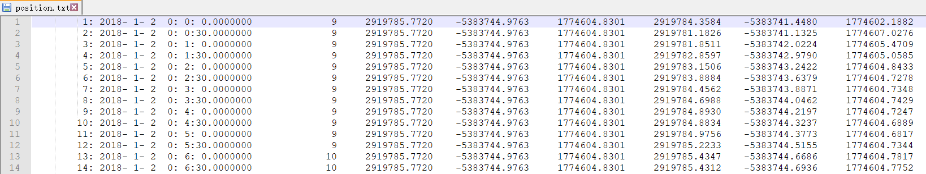

**Fig. 10** Screenshot of position.txt file

1. Epoch_PRN.txt

The Epoch_PRN.txt file saves the epoch number and satellite type. The character position of each column is shown in Table 3. The screenshot of Epoch_PRN.txt file is shown in Fig. 11. The Epoch_PRN.txt can be used to plot and analyze the satellites involved in the calculation for each epoch.

**Table 3** Epoch_PRN.txt format description

|  |  |  |  |
| --- | --- | --- | --- |
| items | | value type | Beginning and ending bytes |
| epoch number | | int | 1-10 |
| satellite type | system number | char | 13-13 |
| satellite number | int | 14-15 |

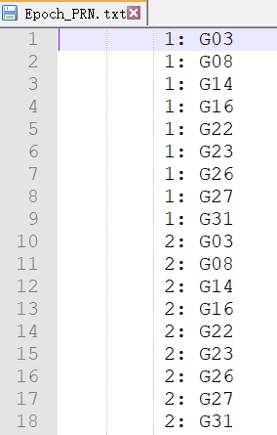

**Fig. 11** Screenshot of Epoch_PRN.txt file

1. ZTDW_Clock.txt

The ZTDW_Clock.txt file saves the epoch number, observation time, zenith total delays (ZTDs), reference receiver clock bias (base_clk_*), and inter-system biases (diff_clk_*). The character position of each column is shown in Table 4. The screenshot of ZTDW_Clock.txt file is shown in Fig. 12. The ZTDW_Clock.txt can be used to plot and analyze the tropospheric delays, receiver clock offsets, and inter-system biases.

**Table 4** ZTDW_Clock.txt format description

|  |  |  |  |
| --- | --- | --- | --- |
| items | | value type | Beginning and ending bytes |
| epoch number | | int | 1-10 |
| observation time (GPST) | Year | int | 13-16 |
| Moth | int | 18-19 |
| Day | int | 21-22 |
| Hour | int | 24-25 |
| Minute | int | 26-27 |
| Second | double | 29-38 |
| zenith total delay (ZTD) (m) | | double | 39-48 |
| reference receiver clock offset (G) (m) | | double | 51-60 |
| inter-system biases (C) (m) | | double | 53-72 |
| inter-system biases (R) (m) | | double | 75-84 |
| inter-system biases (E) (m) | | double | 87-96 |

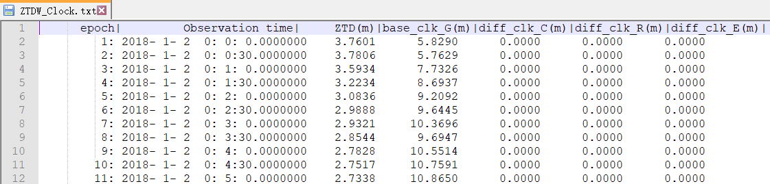

**Fig. 12** Screenshot of ZTDW_Clock.txt file

1. position.kml

The positioning of the MG-APP solution is saved in position.txt, and the XYZ coordinates are converted into the geodetic coordinate system BLH and saved to position.kml. Google Earth can load and display the antenna motion trajectory obtained from PPP solution. The position.kml file is shown on the left side of Fig. 13 and the right side of Fig. 13 is the trajectory in Google Earth.

|  |  |
| --- | --- |
|  |  |

**Fig. 13** position.kml file and coordinate display picture

1. Ambiguity folder

The Ambiguity folder contains ambiguity resolution files for each satellite. The name of ambiguity file consists of the satellite system and the satellite number. For example, the G01.txt save the ambiguity of GPS No.1 satellite. The character position of each column is shown in Table 5. The Ambiguity files format is illustrated in Fig. 14.

**Table 5** Ambiguity file format description

|  |  |  |
| --- | --- | --- |
| items | value type | Beginning and ending bytes |
| epoch number | int | 1-10 |
| GPS week seconds | double | 13-28 |
| number of ambiguities | int | 31-40 |
| ambiguity value (cycle) | double | 43-58 |

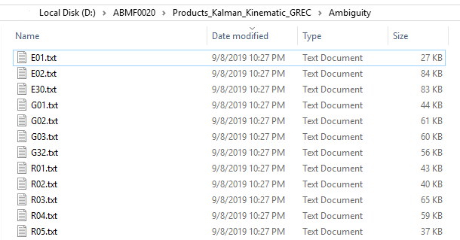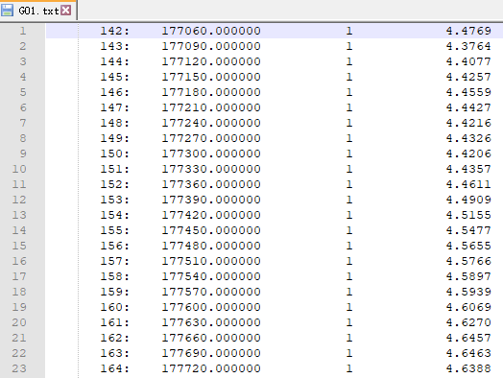

**Fig. 14** Ambiguity files name and data format

1. images folder

When clicking the "Plot" button in the main window of MG-APP, four images will be drawn as shown in Fig. 6, and they will be saved as image files in PNG format into the "image" folder as shown in Fig. 15. "Base_Receiver_Clock.png" is the receiver clock offset image of the reference systeam, "ppp_dXYZ.png" is the PPP filter solution image, "spp_dXYZ.png" is the SPP solution image, and "ZTD.png" is the zenith troposphere solution image.

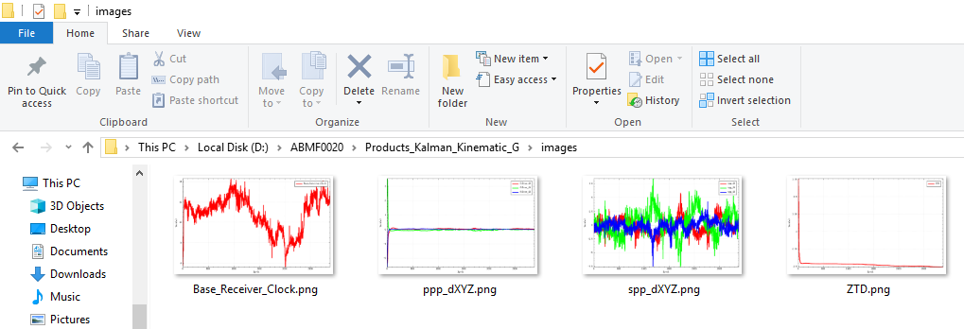

**Fig. 15** Image files saved by MG-APP

1. bad_satellites.txt

MG-APP will store satellites not participating in the calculation in the bad_satellite.txt file, which mainly contains epoch number, satellite number, observation time, and abnormal information. The character position of each column is shown in Table 6. The bad_satellites.txt file format is presented in Fig. 16.

**Table 6** bad_satellites.txt format description

|  |  |  |  |
| --- | --- | --- | --- |
| items | | value type | Beginning and ending bytes |
| epoch number | | int | 1-10 |
| satellite type | system number | char | 13-13 |
| satellite number | int | 14-15 |
| observation time (GPST) | Year | int | 18-21 |
| Moth | int | 23-24 |
| Day | int | 26-27 |
| Hour | int | 29-30 |
| Minute | int | 32-33 |
| Second | double | 35-44 |
| Abnormal information | | String | 47-end |

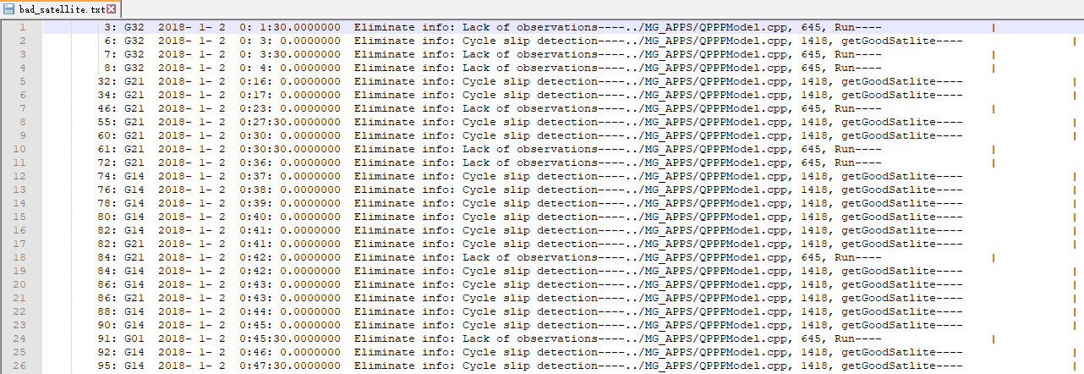

**Fig. 16** Screenshot of bad_satellites.txt file

1. Satellite_info.ppp

Satellite_info.ppp preserves the filtered carrier and pseudorange residuals, satellite coordinates, satellite clock offsets, elevation angles, azimuth angles and various correction models (tropospheric correction, relativistic correction, sagnac correction, tidal correction, antenna height correction, satellite antenna correction, receiver antenna correction, phase wind-up correction, etc.). After data processing, the detailed information of PPP mode will be stored in Satellite_info.ppp file, which can facilitate the analysis of abnormal problems in data processing. Satellite_info.ppp epoch data begins with ">", the first two lines are epoch number and observation time, and the following is the data part. The format of Satellite_info.ppp data part is presented in Table 7, and the screenshot of Satellite_info.ppp illustrates in Fig. 17.

**Table 7** Satellite_info.ppp data part format description

|  |  |  |  |
| --- | --- | --- | --- |
| items | | value type | Beginning and ending bytes |
| satellite type | system number | char | 1-1 |
| satellite number | int | 2-3 |
| carrier filter residual (m) | | double | 6-19 |
| pseudorange filtering residual (m) | | double | 22-35 |
| satellite coordinates(m) | X | double | 38-51 |
| Y | double | 54-67 |
| Z | double | 70-83 |
| satellite clock offset (m) | | double | 86-99 |
| elevation angle (°) | | double | 102-115 |
| azimuth angle (°) | | double | 118-131 |
| slant tropospheric dry delay (m) | | double | 134-147 |
| wet projection function | | double | 150-163 |
| relativistic correction (m) | | double | 166-179 |
| sagnac correction (m) | | double | 182-195 |
| tidal correction (m) | | double | 198-211 |
| antenna height correction (m) | | double | 214-227 |
| satellite antenna correction (cycle) | L1 frequency | double | 230-243 |
| L2 frequency | double | 246-259 |
| receiver antenna correction (cycle) | L1 frequency | double | 262-275 |
| L2 frequency | double | 278-291 |
| phase wind-up correction (cycle) | | double | 294-307 |

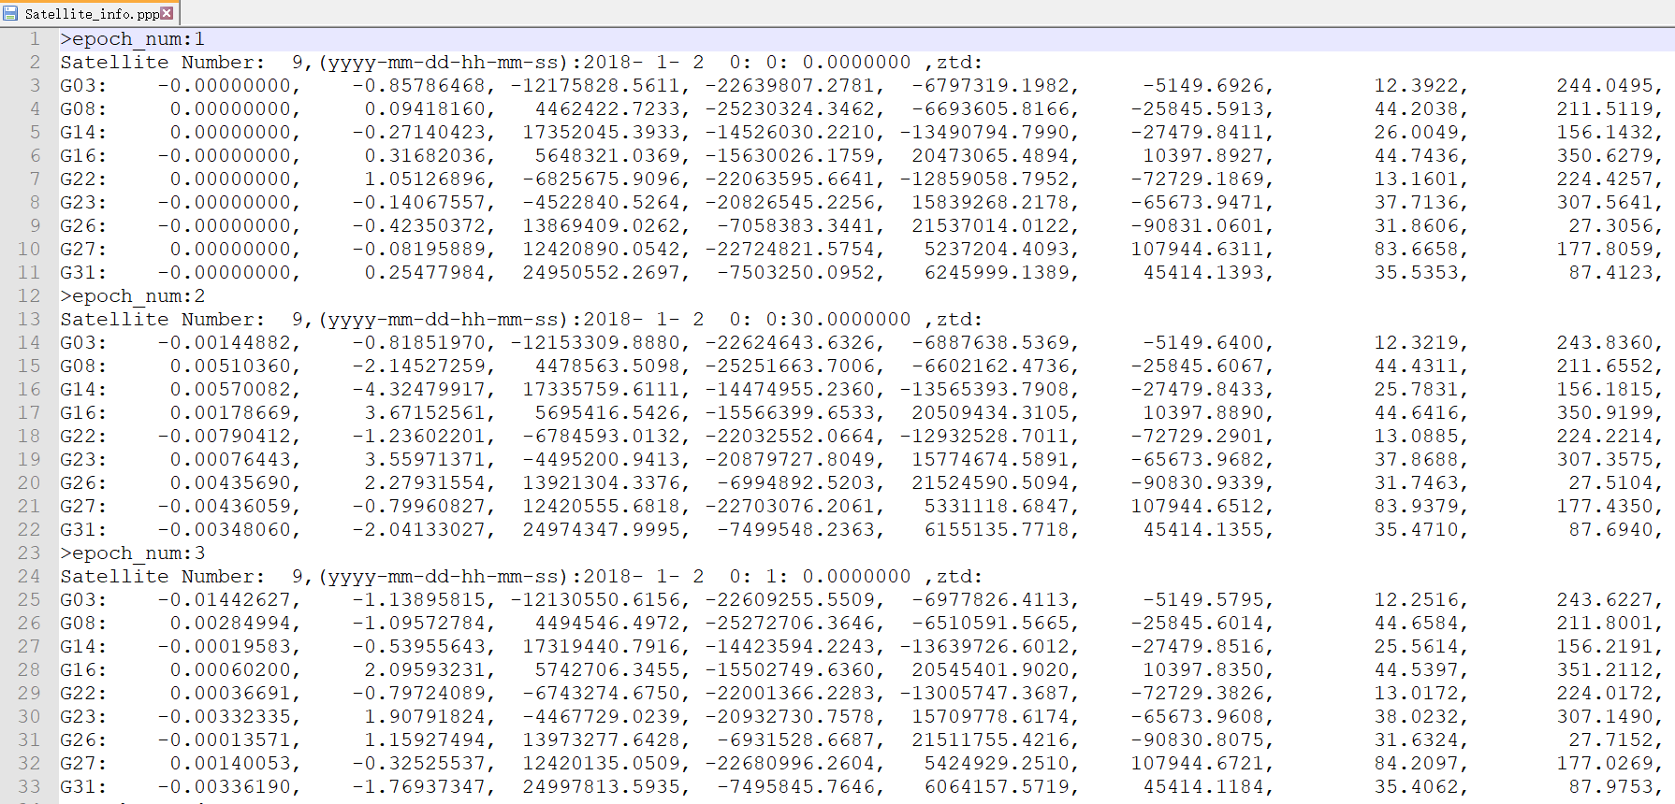

**Fig. 17** Screenshot of Satellite_info.ppp file

**6 Thanks & Support**

We would like to thank the IGS, CNES, and GFZ for providing GNSS data and orbit and clock products. Furthermore, we would like to thank Natural Resources Canada for its latest CSRS-PPP online application. We also appreciate the reviewer Steve Hilla and the editor in chief Alfred Leick for their suggestions on improving the manuscript. In addition, we are grateful to Dashuai Chai, Yulong Ge, Chuanbao Zhao, Xiaolong Mi, Shengliang Wang, Ming Gao and Feng Zhou for their valuable suggestions. We also express our sincere gratitude to some of the software sources listed below.

**Software:**

Qt: <www.qt.io>

Eigen: <eigen.tuxfamily.org>

RTKLIB: <www.rtklib.com>

QCustomPlot: <www.qcustomplot.com>

Any suggestions, corrections, and comments on MG-APP are sincerely welcomed; please contact us. MG-APP will be updated frequently, I hope numerous people can participate in the next update. The software is available on The GPS Toolbox website at: <https://www.ngs.noaa.gov/gps-toolbox/>.

Gongwei Xiao

Email: [xiaogongwei@asch.whigg.ac.cn](mailto:xiaogongwei@asch.whigg.ac.cn?subject=xiaogongwei@asch.whigg.ac.cn)

Github: <https://github.com/xiaogongwei>

MG-APP: <https://github.com/xiaogongwei/MG_APP>

CSDN: <https://blog.csdn.net/xiaoxiao133>

Address: No. 340 Xudong Street, Wuhan City, Hubei Prov. China 430077

**7 References**

Bahadur, Berkay, Metin Nohutcu (2018) PPPH: a MATLAB-based software for multi-GNSS precise point positioning analysis. GPS Solut 22:113. https://doi.org/10.1007/s10291-018-0777-z

Zhou F, Dong D, Li W, Jiang X, Wickert J, Schuh H (2018) GAMP: an open-source software of multi-GNSS precise point positioning using undifferenced and uncombined observations. GPS Solut 22:33. https://doi.org/10.1007/s10291-018-0699-9

Boehm J, H. Schuh (2004) Vienna Mapping Functions in VLBI analyses. Geophys Res Lett 31(1):L01603. https://doi.org/10.1029/2003GL018984

Boehm J, Niell A, Tregoning P, Schuh H (2006) Global Mapping Function (GMF): a new empirical mapping function based on numerical weather model data. Geophys Res Lett 33(7):L07304. https://doi.org/10.1029/2005GL025546

Guo F, Zhang X (2014) Real-time clock jump compensation for precise point positioning. GPS Solut 18(1):41-50. https://doi.org/10.1007/s10291-012-0307-3

Kouba J (2015) A guide to using international GNSS service (IGS) products, September 2015 update. http://kb.igs.org/hc/en-us/articles/201271873-A-Guide-to-Using-the-IGS-Products

Niell, A. E (1996), Global mapping functions for the atmosphere delay at radio wavelengths. J Geophys Res 101(B2):3227–3246. https://doi.org/10.1029/95jb03048